

**DESCRIPTION**

**SUTDENT’S NAME: Harmanpreet singh**

|  |  |
| --- | --- |
| **PROGRAM:** | **Web design** |
|  |  |
| **DATE:** | **09-04-22** |
|  |  |
| **TEACHER’S NAME:** | **Tanu Sood** |
|  |  |
| **COURSE:** | **Fundamental notions of programming** |
|  |  |
| **TYPE OF EXAM:** | **Mid-term** |
|  |  |
| **DURATION:** | **3 hours** |
|  |  |
| **AUTHORIZED MATERIAL:** | **None** |

**OTHER INSTRUCTIONS FROM THE TEACHER**

**The exam has XX6 pages including the cover page. In accordance with the syllabus, the evaluation is worth XX20% of the final grade.**

**Penalties imposed on a student accused of an attempt at plagiarism could include, but are not limited to, a grade of 0% for examination or for the entire course. The student could also be either put on probation, suspended and / or expelled from the program.**

**OTHER INFORMATION**

**Prepared by : Jean-Guy Turgeon**

**Revised by :**

**Approved by :**

**Good luck !**

***Fundamental notions of programming* *Mid-term exam***

**Question 1**

**Briefly explain what is the difference between coding and programming.**

**Ans The translation of human language to the machine language is known as**

**Coding , which can be limited according to instruction given to the coder**

**About the computer needs to accomplish. Programming is a element used to curb the problems**

**With logical approach in order to perform application without error.**

**Question 2**

**High level programming languages needs to be compiled or interpreted before being executed. Explain briefly what compilers and interpreters actually do?**

Ans To translate the source code in Assembly in certain programming languages in the program we need Specific

Program interpreter, which are known as interpreter languages for example Javascript

Php. Some languages allow the source code to be executed with help of intermediate

Program called compilar, these are called compiled languages for instance C Or C++.

**Question 3**

**Low level interpreted script languages such as JavaScript don't need compil-ers, and are interpreted client-side. What does « interpreted client-side » mean?**

**Ans Low level Programming languages are machine dependent such as binary and**

**Or assembly languages , which have to be convert to binary code for that assembler is used that’s why they don’t need compilers and**

**interpreted**

**Question 4**

**Many factors need to be considered when choosing a programming language.**

**Name three of those factors.**

**Ans 1. Targd platform- you should choose language according to the platform.**

**2.Elasticity and performance- the language should let to add the features.**

**3. Library- Language library have solutions of ploblem.**

**Question 5**

**In order for a program to run, two major core components of a computer are needed. Identify those two components from the list below (circle the letters corresponding to your answers).**

1. **Read-only memory (ROM)**
2. **Random-access memory (RAM)**
3. **Central processing unit (CPU)**
4. **Arithmetic & logic unit**
5. **None of the above**

**/3**

**/2**

**/2**

**/3**

**/2**

**2**

***Fundamental notions of programming* *Mid-term exam***

**Question 6**

**What actually does a variable in relation to the computer system?**

**Ans In programming variable is a value we provide to the function or program. It can be changed**

**Or updated according to the program. Program consist of instruction that tell computer what to do and what data need for running.**

**Question 7**

**There are three basic types of programming constructs. Name the program-ming constructs defined below :**

**Programming construct in which each instruction is executed one after another in order of appearance.**

**Ans Sequence**

**Programming construct in which different instructions can be executed depending on the verification of variables.**

**Ans Selection**

**Programming construct in which a block of several instructions is repeated as long as a condition is verified (true).**

**/2**

**/6**

**Ans Loops**

|  |  |
| --- | --- |
| **Question 8** | **/2** |

**What is an algorithm?**

**(Circle the letter corresponding to the right answer)**

1. **A sequence of instructions coded between <script></script> tags.**
2. **The logical step by step fragmentation of a program.**
3. **A visual representation of a program's flow.**
4. **The volume of data transfer between a server and a client.**
5. **None of the above**

|  |  |
| --- | --- |
| **Question 9** | **/2** |

**Briefly explain what is a pseudocode.**

**Ans We need planning to create a good program for that pseudocode is used .to analyze the program**

**It also used and make it possible that entire program should be algorithm starting all inputs and**

**instructions in order to reach desired goal. It is not mandatory but it make program more good because**

**computer need to be told what to do exactly in every circumstance.**

**3**

|  |  |  |
| --- | --- | --- |
| ***Fundamental notions of programming*** | ***Mid-term exam*** |  |
| **Question 10** | **/3** | |

**Below are the most common shapes used in the making of a program's flow chart. Identify three (3) of them.**

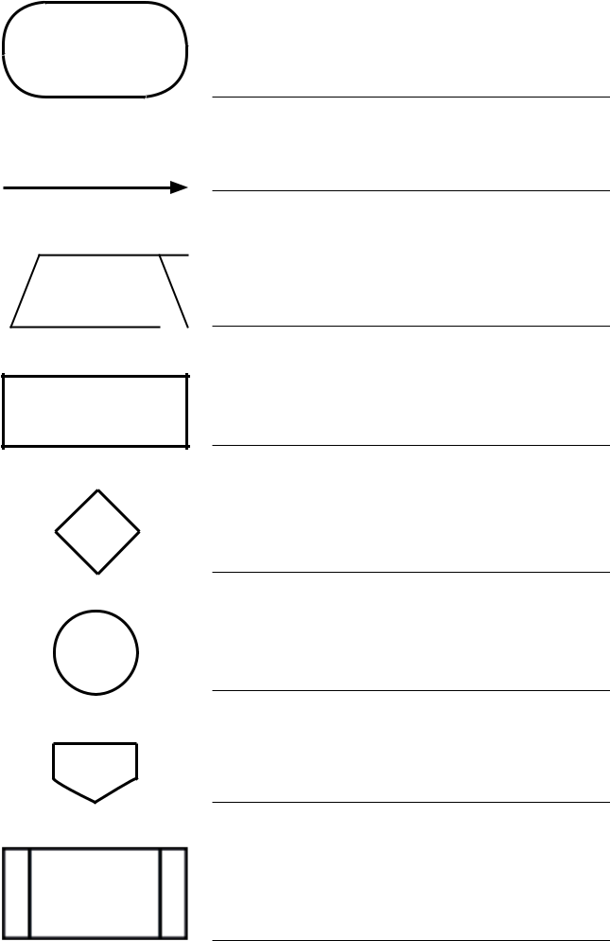

**Terminal**

**Flow lines**

**Process**

**On-page connector**

|  |  |
| --- | --- |
| **Question 11** | **/4** |

**Identify the different data types in the following examples :**

**x = "This is data" String**

**x = 451 Integers**

**x = 2.416 Floating point**

**x = false Boolean**

**4**

|  |  |
| --- | --- |
| ***Fundamental notions of programming*** | ***Mid-term exam*** |
| **Question 12** | **/1** |

**Write a short example of what is « camel case » writing.**

**Ans Camel case is consist of writing sentences in which except the first word all other words started with uppercase.**

**For example myNameIsHarman**

|  |  |
| --- | --- |
| **Question 13** | **/2** |

**(Circle your answer)**

**Is the following variable's name right or wrong?**

***2choices***

**Right Wrong**

|  |  |
| --- | --- |
| **Question 14** | **/4** |

**Briefly explain what are variable's declaration and assignation?**

**Declaration :**

**Ans In the programming certain number is used as a variable which is telling by declaring variables .It can different according to language.**

**For example in php the $ sign and in javascript the words are <var> or <let>.**

**Assignation :**

**Ans Assignation is consists into setting or re-setting the value contained in a variable. = sign is used to do that.**

|  |  |
| --- | --- |
| **Question 15** | **/2** |

**Give the answer to the following arithmetic operation :**

**2+3*4= 14**

|  |  |
| --- | --- |
| **Question 16** | **/3** |

**Based of the following variable, indicate if the conditions are *true* or *false*.**

**$legalAge = 18;**

**17 <= $legalAge True**

**22 > $legalAge True**

**22 != $legalAge True**

|  |  |
| --- | --- |
| **Question 17** | **/3** |

**Briefly explain what is « concatenation ».**

**Ans Concatenation is a process of combine the variables so the we can get answer in one line. For that**

**javascript used plus sign and php uses a period (.) . for example**

**<script>**

**let text1 = "sea";**

**let text2 = "food";**

**let result = text1.concat(text2);**

**document.getElementById("demo").innerHTML = result;**

**</script>**

**5**

|  |  |  |
| --- | --- | --- |
| ***Fundamental notions of programming*** | ***Mid-term exam*** |  |
| **Question 18** | **/4** | |

**Give an example of how to create a function that would be named *myFunction*.**

**Ans Bundle of instruction is performed in a single action which is known as function . It is small**

**Type of program and whenever it is needed ,the function is called . We can use function many time**

**for example , I create function myfunction , which is used to multiply two number a and b and**

**gives the result.**

**<Script>**

**let a = 4;**

**let b = 7;**

**Function myfunction() {**

**result is (a*b);**

**}**

**myfunction();**

**</script>**

|  |  |
| --- | --- |
| **Question 19** | **/1** |

**Briefly explain what is *isNaN()*.**

**Ans It is a short form of not a number and it determine that the data is NAN()**

**or not and return Boolean according to that.**

|  |  |
| --- | --- |
| **Question 20** | **/5** |

**Briefly explain the following relational and logical operators.**

**== Equal : check that the value of two operands are equal and return boolean.**

**=== Equal in value and type: check the value of two operands and type (string or number) and return**

**boolean**

**!= Not Equal : it work same as equal but in reverse order that it check not equal .**

**&& And : used to verify two conditions.**

**|| Or : used to verify one condition.**

|  |  |
| --- | --- |
| **Question 21** | **/5** |

**Explain the following example of a *for* loop.**

**for(i=1; i<=10; i++) {**

**document.write("Number: " + i + "<br />");**

**}**

**Ans Function is in a for loop is used continue as a loop until the condition is true it will continue run but**

**if the condition is not true it don’t work . we creating function where I is starting element .loop starting from 1**

**and it will automatically increment I for each run until condition is true. So for that the output will be 1 to 10 counting**

**and after that the condition is not applicable so it stop running.**

**6**